18) Write a C program to arrange a series of numbers using Merge Sort

PROGRAM:

#include <stdio.h>

void merge(int arr[], int l, int m, int r) {

int i, j, k;

int n1 = m - l + 1;

int n2 = r - m;

int L[n1], R[n2];

for (i = 0; i < n1; i++)

L[i] = arr[l + i];

for (j = 0; j < n2; j++)

R[j] = arr[m + 1 + j];

i = 0;

j = 0;

k = l;

while (i < n1 && j < n2) {

if (L[i] <= R[j]) {

arr[k] = L[i];

i++;

} else {

arr[k] = R[j];

j++;

}

k++;

}

while (i < n1) {

arr[k] = L[i];

i++;

k++;

}

while (j < n2) {

arr[k] = R[j];

j++;

k++;

}

}

void mergeSort(int arr[], int l, int r) {

if (l < r) {

int m = l + (r - l) / 2;

mergeSort(arr, l, m);

mergeSort(arr, m + 1, r);

merge(arr, l, m, r);

}

}

void printArray(int A[], int size) {

for (int i = 0; i < size; i++)

printf("%d ", A[i]);

printf("\n");

}

int main() {

int arr[] = {12, 11, 13, 5, 6, 7};

int arr_size = sizeof(arr) / sizeof(arr[0]);

printf("Given array is \n");

printArray(arr, arr_size);

mergeSort(arr, 0, arr_size - 1);

printf("\nSorted array is \n");

printArray(arr, arr_size);

return 0;

}

INPUT:

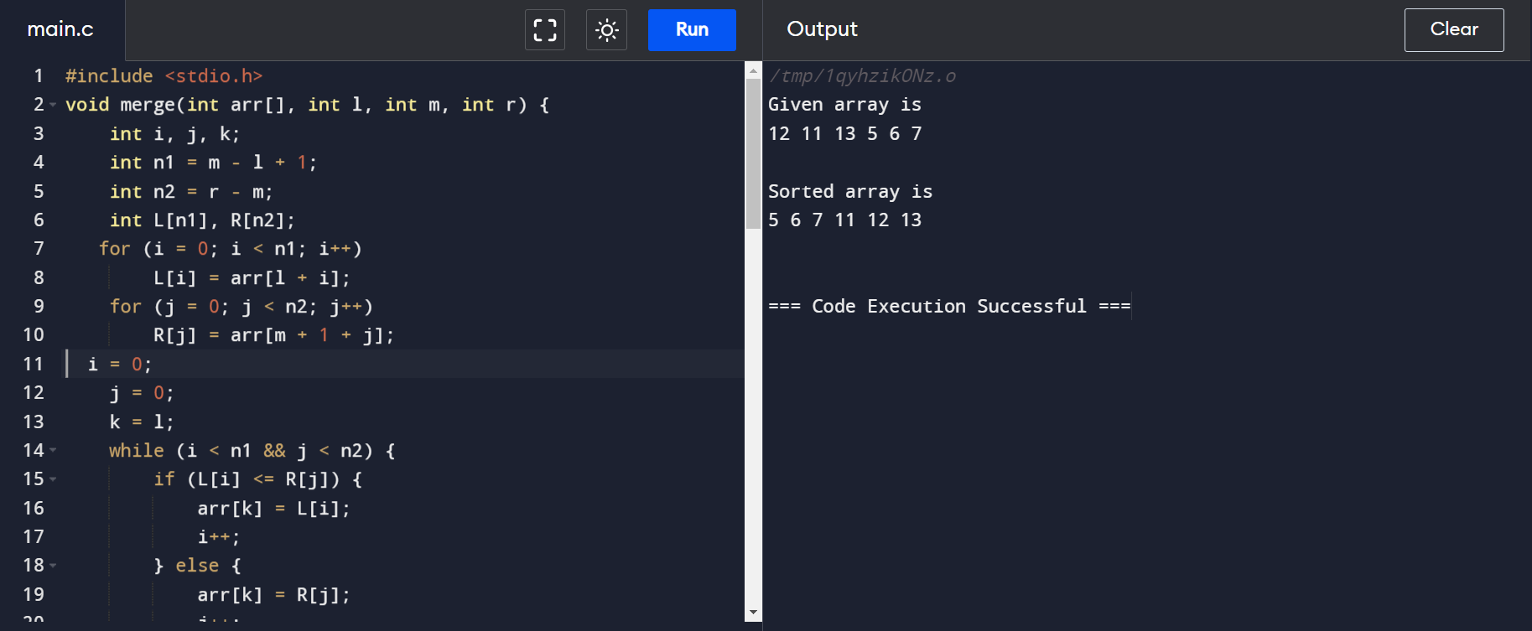

OUTPUT:

